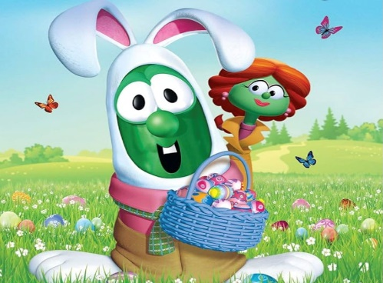
VeggieTales Matinee

Saturday, March 16th 9:30 to 11:00am
UCC Friendship Hall
Bring a Blankie & Come Join Us For
Featured Presentation: “Twas the Night Before Easter
Snacks – Games – Crafts
Closing Prayer
Take Home: Special Easter Basket
Please sign up for the Matinee Event below so that we are sure to have enough snacks, and Special Easter Basket made up for each child in attendance. You may return the form to church office, or contact Ronda Mortenson
by email rkmort60@gmail.com or call 573-694-3933
Childs Name Attending: ________________________________
Emergency Contact Name & Number: ______________________

